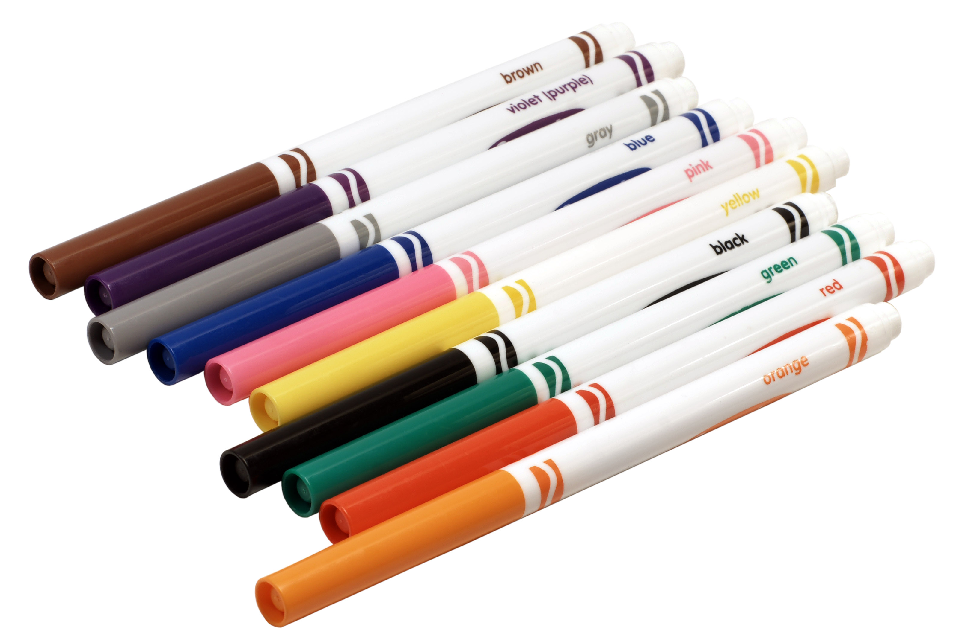
7th Grade Supply List
Ms. Le’s Class, Rm 534

7th Grade Math
- Color Markers (12 Pack)
- Color Pencils (12 Pack)
- 1 or 2 ream(s) of Copy Paper
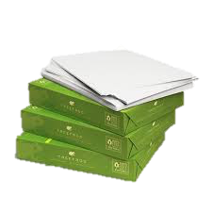
- 2-3 Graph Ruled Composition Notebooks (Any color, 100 sheets)
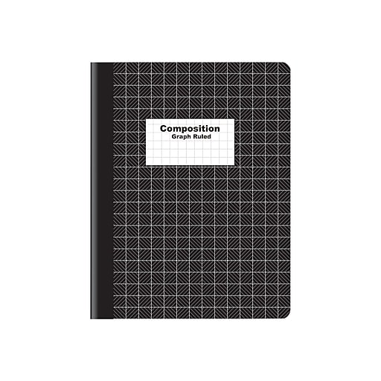
- A Scientific Calculator
- 2-3 Purple or Blue Pen
- A pack of Elmer’s Glue Sticks

- Marcadores de color (paquete de 12)
- Lápices de colores (paquete de 12)
- 1 o 2 resma (s) de papel de copia
- 2-3 cuadernos de composición con reglas de gráficos (cualquier color, 100 hojas)
- Una calculadora científica
- 2-3 bolígrafo rojo o azul
- Un paquete de barras de pegamento de Elmer

Classroom Wish List

- Expo Dry Erase Makers (Black Preferred)
- 1 or 2 ream (s) of Copy Paper
- Lined Binder Paper
- Clorox/Disinfecting Wipes
- Colored Pencils
- Kleenex
- Elmer’s Glue Sticks
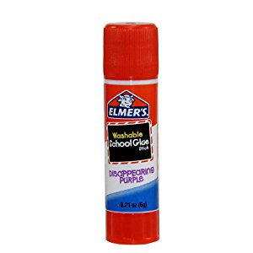
- Graph Ruled Composition Notebooks

Thank you so much/Mucho Gracias!
Ms. Le

